The 5th International Symposium on Transportation Soil Engineering in Cold Regions (TRANSOILCOLD2021)

Zhuhai, Guangdong
From 12th to 14th of November 2021
*The in-country of Mainland China can join both online and offline activities, while the overseas may only join the online one due to the current travel restriction.

- Introduction
Cold regions cover 50% of the land area of the whole world. The construction of infrastructures in cold regions is a critical theme for the development, containing a huge number of demands and challenges. International Symposium on Transportation Soil Engineering in Cold Regions (TRANSOILCOLD) which has been held for four times provides an opportunity for researchers and practitioners in the transportation community to share the research advances and experiences in the infrastructure construction in cold regions.
As a biennial venue, TRANSOILCOLD started in 2013 in Xining, China, followed by TRANSOILCOLD2015 in Novosibirsk, Russia, TRANSOILCOLD2017 in Guide, China and TRANSOILCOLD2019 in St. Petersburg, Russia.
This time, TRANSOILCOLD2021 will be held in 12th-14th, November, 2021 in Zhuhai, China by Sun Yat-sen University, State Key Laboratory of Frozen Soil Engineering and State Key Laboratory of Road Engineering Safety and Health in Cold and High Altitude Regions.
The conference will be held online and offline in Chinese and English (simultaneous interpretation available), with additional online English and Russian sub-venues. Given the travel restrictions in mainland China due to COVID-19, overseas will have the online conference while the in-country can take the both.
The theme of this venue is “Key scientific issues and challenges in the transportation infrastructure in cold regions” with the following subtopics:
- Roadbed and foundation engineering in cold regions
- Soils frost heave and thaw settlement in cold regions
- Structure-soil interaction in cold regions
- Soil dynamics in cold regions
- Performance of infrastructures in cold regions
- Construction and maintenance of infrastructures in cold regions
- Arctic engineering and environmental disaster effect
- Theoretical technology and practice of construction by freezing method
- Advisory committee
Chair: Cheng Guodong, Chen Xiangsheng
Member: Ling Xianchang, Liu Bo, Ma Qinyong, Ma Wei, Sheng Daichao, Taisia Shepitko V. Lutsky, Wu Qingbai, Yang Gengshe, Yang Ping, Ye Yangsheng, Zhang Luxin, Zhou Guoqing
- Academic committee
Chair: Lai Yuanming, Wang Shuangjie
Member: Alexander Isakov, Andrey Petriaev, Askar Zhussupbekov, Bill Yu, Ding Lin, Erol Tutumluer, Evgeny Ashpiz, Fang Jianhong, Jin Huijun, Jong-Sub Lee, He Ping, Li Dongqing, Li Guoyu, Li Xu, Li Yongqiang, Liu Jiankun, Ma Jianlin, Niu Fujun, Qi Jilin, Satoshi Akagawa, Sergey Kudriavtsev, Shan Wei, Shen Yanjun, Shen Yupeng, Sheng Yu, Su Qian, Sun Binxiang, Tatsuya Ishikawa, Wang Lianjun, Wang Qing, Wang Xinglong, Wang Xu, Wei Changfu, Wen Zhi, Wu Zhijian, Xiong Zhang, Xu Xiangtian, Yang Weihao, Yu Wenbing, Yue Zurun, Zhang Jianming, Zhang Juan, Zhang Mingyi, Zhang Qianli, Zhang Sheng, Zhang Wuyu, Zhao Xiaodong, Zhaohui Yang, Zhou Xiaomin
- Organizing committee
Chair: Erol Tutumluer, Wang Fuming
Vice-chair: Liu Jiankun, Wang Shuangjie
Member: Alexander Isakov, Andrey Petriaev, Bagdat Teltayev, Cai Degou, Chang Dan, Chen Jianbing, Cheng Qiangong, Cui Yinghui, Evgeny Ashpiz, Fang Jianhong, Fu Zhipeng, Guo Chengchao, Han Longwu, Li Dongwei, Li Ting, Liang Siming, Lin Hongjie, Lin Zhanju, Liu Enlong, Mu Yanhu, Niu Fujun, Peng Liyun, Qi Jilin, Sergey Kudriavtsev, Shen Yanjun, Tai Bowen, Tang Liang, Tang Liyun, Tian Yahu, Wang Dayan, Wang Pengcheng, Wang Qingzhi, Wang Tengfei, Wang Tianliang, Wang Zuo, Wu Zhijian, Xu Anhua, Xu Xiangtian, Yan Han, Yu Wenbing, Yue Zurun, Zhang Feng, Zhang Qianli, Zhang Sheng, Zhang Xuefu, Zhang Yu, Zhang Ze, Zhao Xiangqing, Zhou Xiaomin
- Young committee
Chair: Chang Dan, Li Xu
Member: Bai Ruiqiang, Chen Xiaobin, Chzhan Andrei, Cui Yinghui, Ekaterina Kravchenko, Gao Jianqiang, Han Fenglei, He Xiaonan, Hu Tianfei, Ji Yukun, Ji Zhiqiang, Jiang Guojing, Jin Long, Li Anyuan, Li Qionglin, Li Shuangyang, Liang Siming, Lin Hongjie, Lin Luobin, Liu Minghao, Liu Xiaoqiang, Luo Jing, Luo Tao, Ma Dongdong, Ma Qinguo, Ming Feng, Mu Yanhu, Muge Elif Orakoglu, Niu Yaqiang, Pei Wansheng, Peng Liyun, Qin Yinghong, Qin Zipeng, Ren Jingge, Shen Yanjun, Tai Bowen, Teng Jidong, Wan Xusheng, Wang Chong, Wang Dongyong, Wang Liyang, Wang Pengcheng, Wang Qingzhi, Wang Tengfei, Wang Tianliang, Wen Wei, Wu Tao, Xiao Yuanjie, Xiao Zean , Xu Yan, You Tian, You Zhemin, Yu Fan, Zeng Hongyan, Zhang Feng, Zhang Jiwei, Zhang Jin, Zhang mingli, Zhang Song, Zhang Xiyi, Zhang Yu, Zhang Yuzhi, Zhang Ze, Zhang Zhongqiong, Zhao Xiangqing, Zhao Yanhu, Zheng Hao, Zhou jiazuo, Zhou Yuanfu, Zhou Zhiwei

- Organizer
- Sun Yat-sen University, China
- State Key Laboratory of Frozen Soil Engineering, China
- State Key Laboratory of Road Engineering Safety and Health in Cold and High Altitude Regions, China
- Co-organizer
- Beijing Jiaotong University, China
- China University of Mining and Technology, China
- Far Eastern State Transport University, Russia
- Harbin Institute of Technology, China
- Journal of Sciences in Cold and Arid Regions, China
- Korea University, Republic of Korea
- Nanjing Tech University, China
- National Field Scientific Observation and Research Station of Qinghai-Tibet Plateau Highway Frozen Soil Engineering, China
- Northwest Research Institute Co., Ltd of C.R.E.C, China
- Qinghai University, China
- Qinghai Research Institute of Transportation (QRIT), Department of Transportation (DOT) of the Qinghai Province, China
- Russian University of Transport (MIIT), Russia
- Shijiazhuang Tiedao University, China
- Siberian State University of Railway Engineering, Russia
- St. Peterburg State University of Railway Engineering, Russia
- State Key Laboratory for Geomechanics and Deep Underground Engineering, China University of Mining and Technology, China
- State Key Laboratory of Mountain Bridge and Tunnel Engineering
- TC202, ISSMGE
- The First Highway Consultants Co., Ltd, China
- Transportation Geotechnics Committee of China
- University of Alaska Anchorage, US
- University of Illinois at Urbana-Champaign, US
- Venue
Sun Yat-sen University Wushunde Academic Communication Center, Xiangzhou, Zhuhai, Guangdong, China

- Conference agenda (Beijing Time)
- November 12
11: 00-22: 00 Registration (Offline)
18: 30-21: 30 Postgraduate session
- November 13
08: 30-09: 00 Opening ceremonies
09: 00-12: 10 Keynotes
12: 10-14: 00 Lunch
14: 00-18: 00 Sub-venue sessions
18: 00-19: 30 Banquet
- November 14
08: 30-12: 00 Sub-venue sessions
12: 00-14: 00 Lunch
14: 00-17: 10 Keynotes
17: 10-17: 40 Awards and closing ceremonies
- Conference paper submission
Submitted full papers with peer review will be published in Sciences in Cold and Arid Regions (SCAR).
Submission link: www.scar.ac.cn, and choose the submission column “TRANSOILCOLD2021”
Please submit the full paper on or before 1st November 2021
- Outstanding paper award
Shortlisting conditions: (1) Full-text papers will be published in the SCAR special issue after peer review; (2) The authors should make the report by themselves or representatives on the spot.
Judging rules: (1) Nominated by the SCAR journal editorial department; (2) Nominating papers, the organizing committee invites 5 senior professors to conduct anonymous letter reviews on the papers, and rank the average points.
Notes: The nomination will be announced before the conference open. Award winners will take the acceptance at the end of conference.
- Outstanding report of postgraduate student award
Shortlisting conditions: (1) The student should do the oral presentation online or on spot; (2) The presentation materials (PowerPoint files and related papers) should be sent to the conference e-mail at least one week before the presentation; (3) The corresponding paper should be published in recent three years or under review, which can be published in any journal; (4) The first author should be the student himself/herself, or the first one is his/her supervisor while the student being the second.
Judging rules: (1) The presentation will be rated by two hosts and three reviewers on spot, which accounts for 60%; (2) the presentation materials will be rated by senior reviewers via correspondence, which accounts for 40%。
Notes：（1）Those who have won the outstanding paper award will NOT be considered in this award; (2) The result will be determined after the postgraduate session, and winners will be awarded on the closing ceremonies.
- Keynote speakers (Tentative)
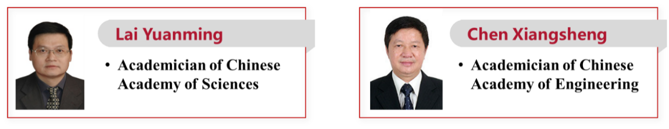
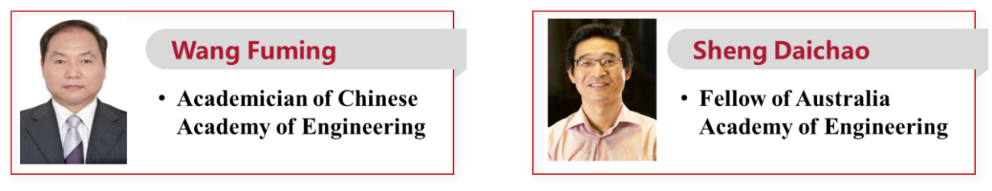
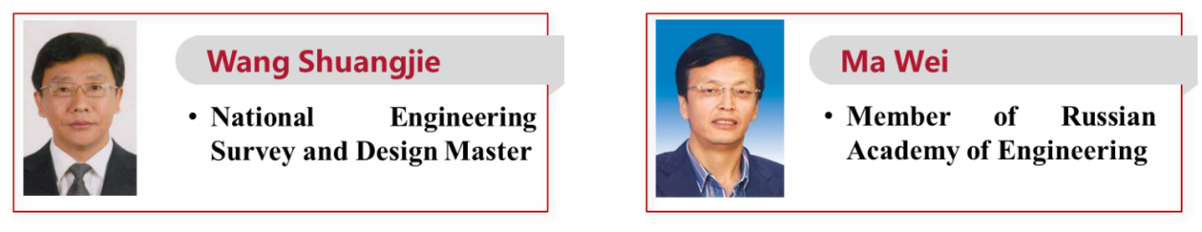
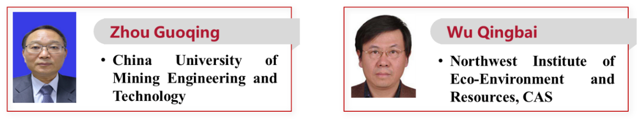
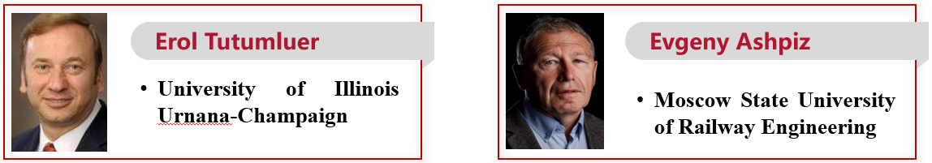
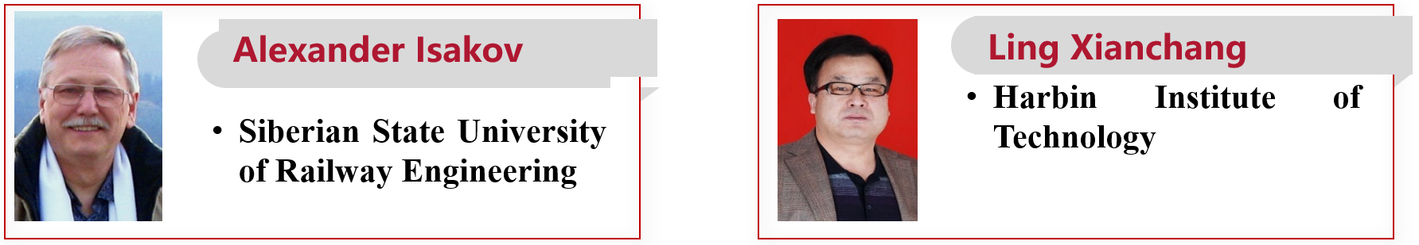
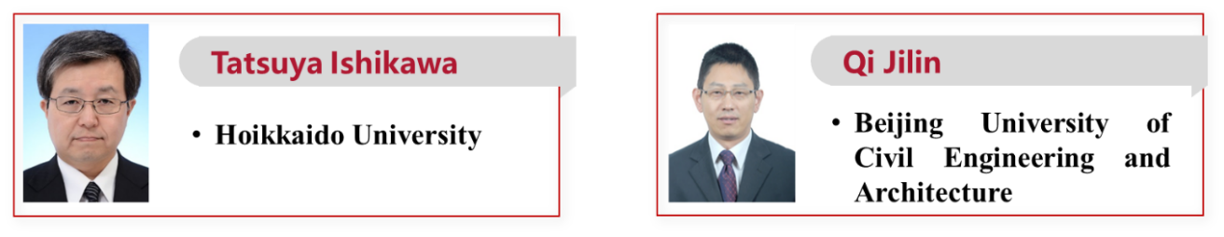
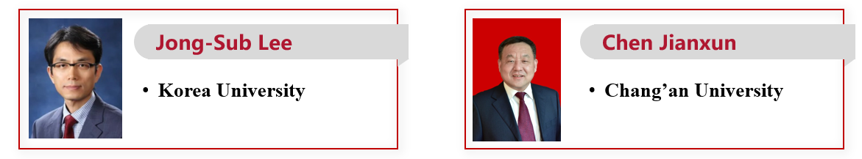
- Conference registration and payment:
- Registration for online conference:
- Registration method
Online registration: http://transoilcold2021.csp.escience.cn/, select “Registration Information”, download the receipt form, fill in the form and send it to the conference email: transoilcold2021@163.com.
- Charging fee
The online conference is free of charge.
- Registration for offline conference:
- Registration method
Online registration: http://transoilcold2021.csp.escience.cn/, select “Registration Information”, download the receipt form, fill in the form and send it to the conference email: transoilcold2021@163.com.
- Charging fee
Regular representative: Before October 15, RMB 2,000/person; After October 15, RMB 2,400/person.
Student representative: Before October 15, RMB 1,200/person; After October 15, RMB 1,600/person.
Accompany person: RMB 600/person (Only meal coupons, no meeting materials).
- Payment method (please note "name of participant unit + participant name" when paying online):
(1) Payment to public transfer:
Account Name: Guangzhou Aoguang Culture Communication Co., Ltd.
Bank account number: 4400 1431 9010 5301 2501
Bank: China Construction Bank Co., Ltd. Guangzhou Chigang Branch
(2) On-site payment: cash, credit card, Alipay, WeChat are all acceptable.
Notes: The conference fee invoice is entrusted to Guangzhou Aoguang Culture Communication Co., Ltd. to open the conference affairs ticket. If you have any special needs, please contact the conference affairs team. The accommodation fee invoice is issued by the hotel staying in.
- Contact
Email: transoilcold2021@163.com
Website: http://transoilcold2021.csp.escience.cn
Event Coordinators:
- General coordinator: Chang Dan, 13811483383, changd@mail.sysu.edu.cn
- English coordinator: Lin Hongjie, 13805015118, linhj33@mail.sysu.edu.cn
- Russian coordinator: Kravchenko Ekaterina，79287531530, kravchienko.66@bk.ru
- Chinese coordinator: Tai Bowen, 18813071022, taibw@lzb.ac.cn

