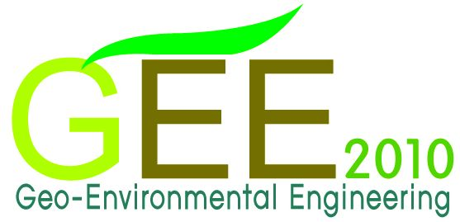 | 
9th International Conference on Geo-environmental Engineering (GEE 2010)

May 7 ~ May 8, 2010
Seoul National University, Seoul, Korea

Invitation
Geo-environmental Engineering has become an issue of great concern and importance in recent years, since urban areas, landfill sites, and army base camps have suffered from soil and groundwater contamination. Numerous researches have been focused on testing, monitoring and field investigation, fate and transport of contaminants, remediation and management of contaminants, wastes landfills and geosynthetics.
The objective of GEE is to exchange the geo-environmental knowledge and to give young researchers for presenting and discussing their researches through basic philosophy of encouraging young researchers. Since 2001, GEE has been held annually in Seoul (Korea), Kyoto (Japan) and Grenoble (France).
On behalf of the organizing committee, we are pleased to inform you of the 9th International Conference on Geo-environmental Engineering (GEE 2010). The meeting will take place from May 7~8th 2010 at Seoul National University, Seoul, Korea. The main themes of GEE 2010 are as bellows.

Themes
- Green Remediation
- Brownfields Redevelopment
- Other Geo-Environmental Issues
Testing, Monitoring and Field Investigation
Fate and Transport of Contaminants
Remediation and Management of Contaminants
Wastes, Landfills and Geosynthetics

Submission of Abstracts
Authors are invited to submit abstract of about 200 words in the topics outlined above written in English on A4 size paper. A figure and/or a table can be included in the abstract. Abstract submission deadline is January 31, 2010 and the date of abstract acceptance notice is February 28, 2010. Send the abstract to gee2010snu@gmail.com. In addition, registration form also needs to be sent beforehand with abstract. Format of abstract and registration form can be downloaded from the homepage. All abstracts will be referred by the program committee for originality, scientific merit and relevance to the conference themes.
After acceptance of the abstract, the paper instructions will be informed of each paper author. The deadline of full paper is March 31, 2010. Please reference the homepage for further information of paper format. Papers will be also peer reviewed by organizing committee, and if selected, will be published in the proceeding of GEE 2010 and will be available at the time of registration. Also, papers can only be presented in English during the conference.

Registration Fee
The registration fee is FREE.

Important Dates
- Abstract Due: January 31, 2010
- Notice of Acceptance: February 28, 2010
- Full Paper Due: March 31, 2010

Advisory Chair
Masashi Kamon (Kagawa National College of Technology, Japan)

Organizing Committee
Junboum Park (Seoul National University, Korea) – Committee Chair (junbpark@snu.ac.kr)
Ha-Ik Chung (Korea Institute of Construction Technology, Korea)
Takeshi Katsumi (Kyoto University, Japan)
Jean-Pierre Gourc (University Joseph Fourier, France)
Loretta Li (Vancouver, BC, Canada)

Conference Student Chair (Contact)
Heesoo Woo
Research Associate, Dept. of Civil & Environmental Engineering, Seoul National University,
Seoul, Korea 151-742
Phone) +82-2-880-8733
Fax) +82-2-875-6933
E-mail) gee2010snu@gmail.com

For further information, visit http://gee2010.snu.ac.kr

